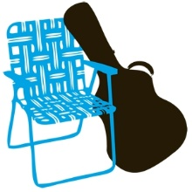
SPONSOR
VEHICLE ACCESS PASS
AT THE MAPLEWOODSTOCK FESTIVAL ON JULY 13TH AND 14TH 2024.
It is being driven by a Maplewoodstock Sponsor and is permitted to park on Dunnell Road or Oakview Avenue.
DRIVER: Show to Police Officer and display on your dashboard when parked.

