2025 Maplewoodstock Music and Arts Festival
Township Department Heads Meeting Agenda

Introductions
Administration
- Event application submitted
- Social Affairs permit received
- Insurance obtained and COI submitted to township
DPW
- Dumpsters – same as last year
- Trash and recycling receptacles
  - We would like additional recycling bins
- Light towers: How many may be available? How can we request / do we need to obtain extras?
- Access to electrical boxes on Oakview and backstage
- Set up
  - Stage will arrive Friday morning
  - Stakes for walking lanes
  - Snow fencing behind the stage
  - Snow fencing for the beer garden
  - Snow fencing for the 60/90 baseball field
  - Snow fencing around one tree in park
  - Note: Working with Conservancy for other tree protection
Police / Security
- Proposed security attached – requesting quote and discuss traffic
- Propose Oakview one-way from Dunnell to Valley
- Dunnell and Baker (from Dunnell to Valley) have parking reserved for vendors, bands & volunteers – could we use cones and signs to mark parking, in addition to sawhorses
- Emergency egress lanes and barriers in front of stage
EMS / SORS: rig, cooling tent and personnel on site – could we request for generator from DPW
Food Vendor Permits
Sensory activation area – same as last year; SAV provided by South Orange and being delivered Friday
Maplewoodstock 2025 Map
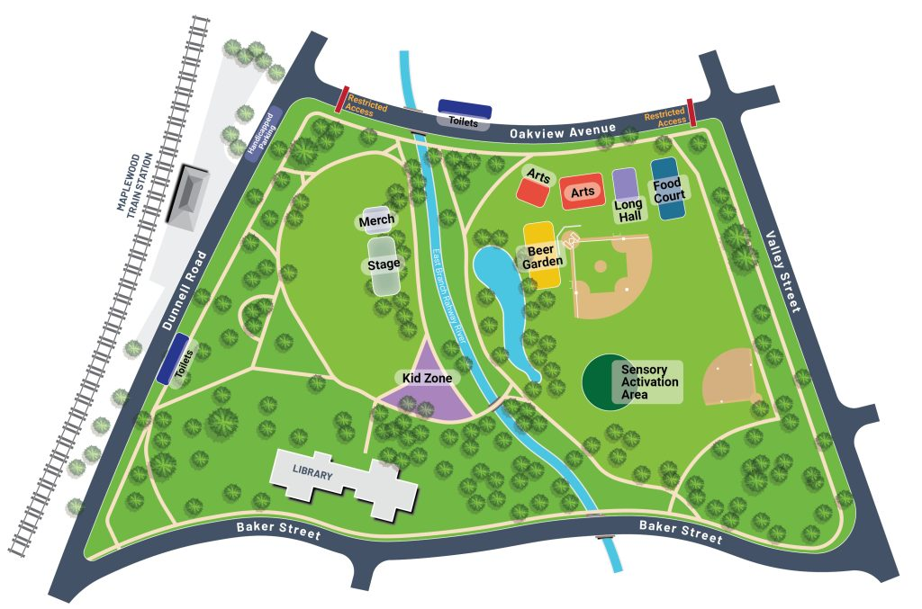

Tents
Long Hall Tent: 30x60 – permit awarded
Beer Garden
- Three 20x40 tents
- Three 10x20 tents
Sensory Activation Area: 10x20 pop up tent
Merchandise Tent: 10x20 pop up tent
Sponsor Tent along front of field between stage and Oakview: 10x20 pop up tent
Backstage
- 10x10 frame tent with sides
- 10x 20 pop up tent
- Two 10x10 pop up tents
Misting Tent at top of hill, across from train station: 10x20 pop up tent
Maplewoodstock 2025 – Proposed Security Needs

 | Saturday | Sunday
Beer Garden  1 officer | Noon to 9pm | Noon to 9pm
Kid Zone / Hill Field  1 officer | Noon to 9pm | Noon to 9pm
Stage Security  1 officer  2 officers (from Beer / Kid) | 4pm to 11pm  9pm – 11pm | 4pm to 11pm  9pm – 11pm
General Event Security  3 officers (1 East Field, 2 Hill Field)  5 officers (1 East Field, 4 Hill Field) | 2pm – 5pm  5pm – 11pm | 2pm – 5pm  5pm – 11pm
Traffic  2 officers – 1 at Valley & Oakview &  1 at Dunnell & Oakview | 10am thru 11pm | 10am thru 11pm

