FOR IMMEDIATE RELEASE: Contact: Tom Kerns
Phone #: 973-309-1619
Email: kernst@comcast.net

MAPLEWOODSTOCK 2023 ANNOUNCES HEADLINERS

The eighteenth Maplewoodstock will take place on Saturday, July 8th and Sunday, July 9th. Music begins at 12:00 pm each day.

We are excited to announce this year’s headliners. Saturday will feature Red Baraat at 6:45 and Mihali at 8:30.

Red Baraat is a pioneering band from Brooklyn, New York. The group has drawn worldwide praise for its singular sound, a merging of hard driving North Indian bhangra with elements of hip-hop, jazz and raw punk energy.

Mihali is Maplewood-born, solo singer, songwriter, guitarist, artist, and Twiddle co-founder. He follows reggae’s evolutionary ebb and flow, existing in a perpetual state of inspiration and creation, and remaining committed to sonic evolution. Mihali’s music entwines reggae spirit, fluid soundscape architecture, and invigorating mantras.

Sunday’s headliners are Remember Jones at 6:45 and Louis Cato at 8:30.

Remember Jones is a one-of-a-kind soul/pop singer, storyteller and bandleader with a throwback vibe and authentic energy. Often backed and supported by a large ensemble of musicians, his original music and creative, theatrical events have played to countless packed and sold-out clubs and theaters throughout the United States.

Louis Cato is a multi-instrumentalist who plays bass, guitar, percussion, low brass, and others, in addition to vocals. He is also a songwriter, with one album to his credit and a second in production and the band leader for Stephen Colbert “The Late Show” house band.

From a record number of over 120 submissions, eighteen other bands were selected to perform throughout the two days, including the late Jim Buchanan’s JB Blues Band and other local and regional artists.

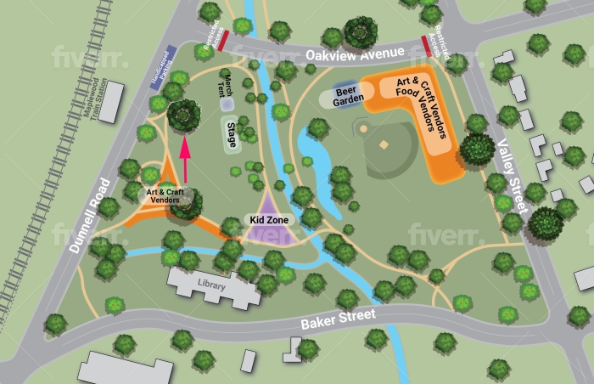

Maplewoodstock is a free event held in Memorial Park in a natural amphitheater, steps away from the Maplewood train station. It features approximately 25 food vendors, 120 art vendors, 20 Kidzone vendors and, of course, a beer and wine garden.

With much support from local businesses and t-shirt sales, Maplewoodstock continues to be true to its mission of presenting the best possible show for the community and of the community with nationally known closing acts and a collection of regional bands with strong Maplewood and South Orange representation.

Canopies are only permitted to those selected via the Canopy Lottery system. The details of the lottery process will be announced closer to the event. DO NOT BRING A CANOPY to the event if you were not selected in the lottery. The rest of the hill will be full of chairs and blankets and neighbors sharing what has become Maplewood’s biggest annual social gathering.

Please note that while the Township of Maplewood strongly supports Maplewoodstock, this is not a Township event. It is organized and managed by the Maplewoodstock Volunteer Committee. For more information, band lineup schedules, inquiries or if you wish to donate please visit www.maplewoodstock.com.

