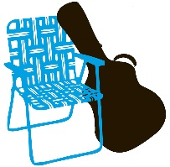
Maplewoodstock 2025
Meeting Follow-Ups March 13, 2025
What | Who | When
Pull all possible tshirt art files | Jamie | March 24
Determine if we can make a poster of the designs | Anyone?
Reach out to Rick for other sounds ideas for East Field and other lighting ideas for the hill | Susan | March 17
Find out how we can get a banner over Maplewood Ave and Springfield | Susan | April 1
Meet with graphic designer | Jim Jamie Others? | March 17 or 18
Review tshirt designs | All | March 28
Final tshirt design |  | April 4
Revise East field layout | Brad & Jim | April 4
Create general map for the program | Brad & Jim | April 5
Provide Gary with a photography retrospective of 20 years | Jamie | March 31
Provide Gary with a feature article of the 20 under 20 art installation | Amy | March 31
Provide Gary with a list of donor names | Brad | April 4
Band Committee Meeting | Band Committee | March 27
Band Committee decisions | Band Committee | April 2
Band Line up drafted | Band Committee | April 5
Send letters to accepted and waitlisted bands | Susan | April 6
Layout line up pages | WHO? | April 8
Review program with committee | Gary | April 9 or 10
Bands must reply |  | April 13
Final program to Charlie | Gary | April 18
Send letters to rejected bands | Susan | April 18

