The Garden State Chapter of ASHI

Presents this certificate to

«First_Name__» «Last_Name__»

For the successful completion of a seminar on the topics of

Report writing & defect recognition

And is awarded 2 ASHI MRC’s and *2 New Jersey CEU’s
Given on December 10, 2020 in Virtual Meeting

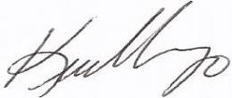
Kevin Vargo
President

- Contributes to State of New Jersey HIAC continuing education requirements for report writing (Pursuant to N.J.A.C. 13:40-15.2)

