FROM ALL GLASS NJ LLC
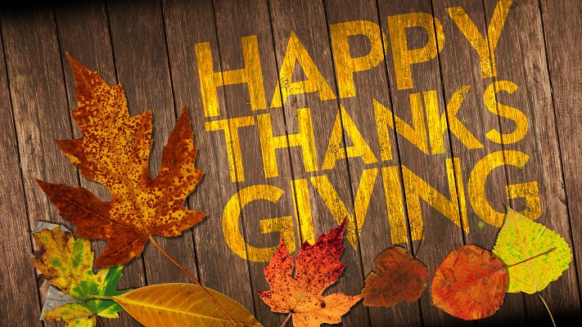
Mention this code
“GLASS 10”
To receive 10% off your next home repair
Call us from a Free Estimate
(973) 902-8047
www.allglassnj.net

We will be closed on Thursday, November 24th

